Given the root of a binary tree, return all **duplicate subtrees**.

For each kind of duplicate subtrees, you only need to return the root node of any **one** of them.

Two trees are **duplicate** if they have the **same structure** with the **same node values**.

**Example 1:**

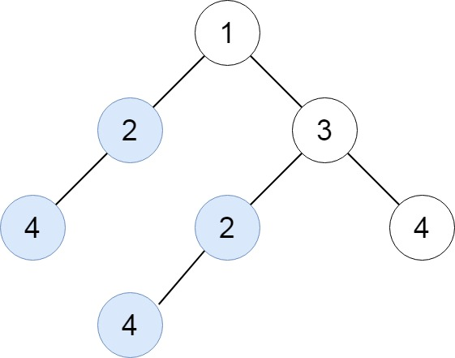

**Input:** root = [1,2,3,4,null,2,4,null,null,4]

**Output:** [[2,4],[4]]

**Example 2:**

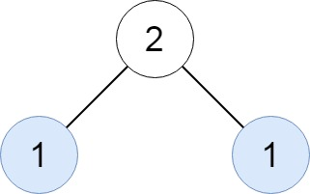

**Input:** root = [2,1,1]

**Output:** [[1]]

**Example 3:**

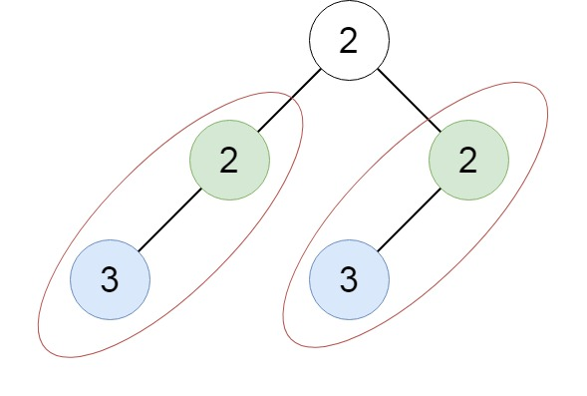

**Input:** root = [2,2,2,3,null,3,null]

**Output:** [[2,3],[3]]

**Constraints:**

* The number of the nodes in the tree will be in the range [1, 10^4]
* -200 <= Node.val <= 200